Change 1 :- On a very first scroll



Change 2 :- At a registration page



Replace register now with registration form and remove the star and remove “Avail E-Tax Filing Services worth Rs. 1144/- Free”

And put below line above *NOTE :

Detailed Tax E-filing worth Rs 1149/- FREE – Ask us how you can avail this for FREE.

Harvard Story on scroll 3 :- Put in a below format

Goals – define to achieve more.

An interesting study was conducted with 100 students of the Harvard University – batch of 1997. Each student were asked 2 questions –

1. If they had set any Goals for themselves.
2. Did they write these Goals down?

The batch finally got segregated into 3 batches –

1. There were 84 students who did not have any set Goals.
2. There were 13 students who had set Goals but they did not write or planned a road-map
3. Only 3 students had Written Goals.

After 10 years the team assessed how these students fared in life. The students who had merely decided some Goals in their mind achieved twice as much as their counter-parts who did not have any Goals but the students who had Goals and had written them down achieved 10 times more than the entire A + B groups put together.

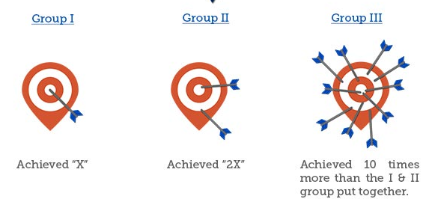

**Fourth Scroll looks fine only change the content :-**

**#FPSelfie**

Don’t leave your finances to chances, plan for it.

**Fifth Scroll**

Add media page which you have added in Landing page